12. ReactJS-HOL

Create a React Application named “ticketbookingapp” where the guest user can browse the page

where the flight details are displayed whereas the logged in user only can book tickets.

The Login and Logout buttons should accordingly display different pages. Once the user is logged in the User page should be displayed. When the user clicks on Logout, the Guest page should be displayed

# code:

PS C:\Users\lenovo> node –v V22.17.0

PS C:\Users\lenovo> npm -v 10.9.2

PS C:\Users\lenovo> npx create-react-app ticketbookingapp PS C:\Users\lenovo\ ticketbookingapp > npm start

App.js

import React, { useState } from 'react';

import GuestPage from './components/GuestPage'; import UserPage from './components/Userpage'; import './App.css';

function App() {

const [isLoggedIn, setIsLoggedIn] = useState(false);

const handleLogin = () => setIsLoggedIn(true); const handleLogout = () => setIsLoggedIn(false);

return (

<div className="App">

<h1>Ticket Booking App</h1>

<div style={{ marginBottom: '20px' }}>

{isLoggedIn ? (

<button onClick={handleLogout}>Logout</button>

) : (

<button onClick={handleLogin}>Login</button>

)}

</div>

{isLoggedIn ? <UserPage /> : <GuestPage />}

</div>

);

}

export default App;

Src/components/Userpage.js

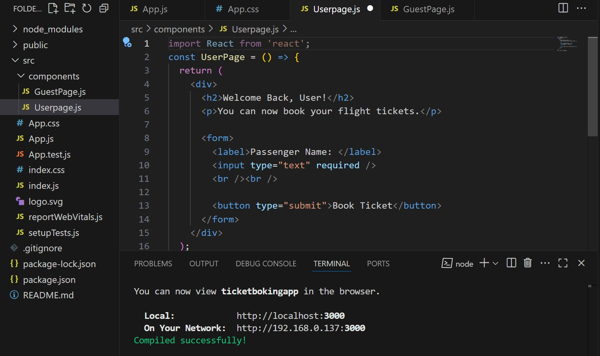

Src/components/Guestpage.js

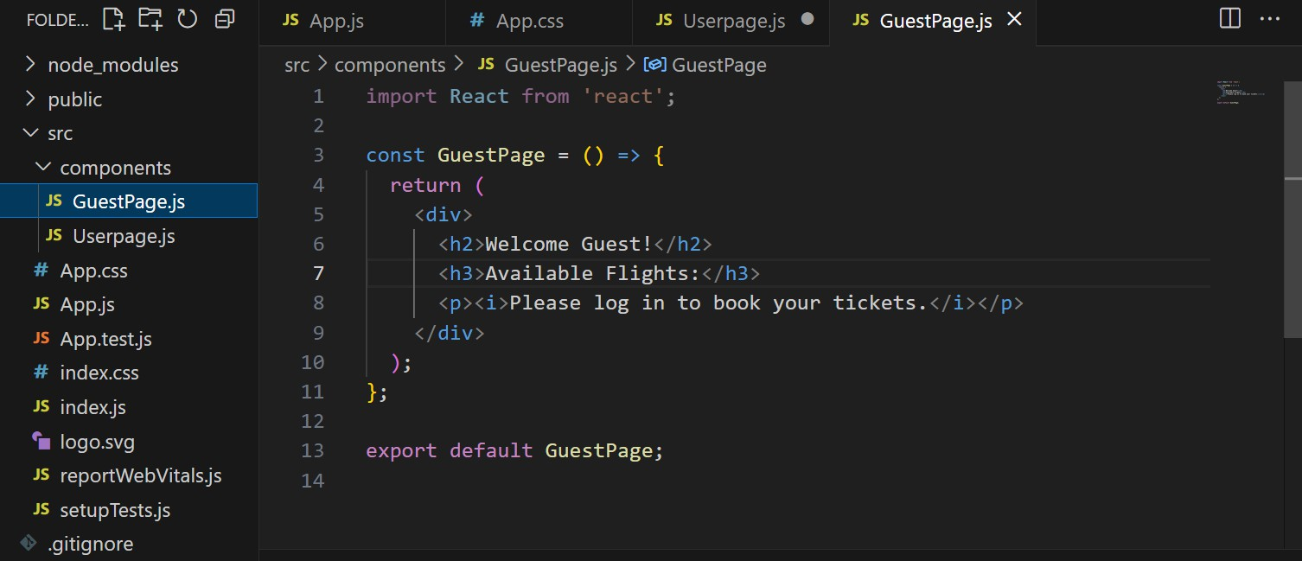

# Output:

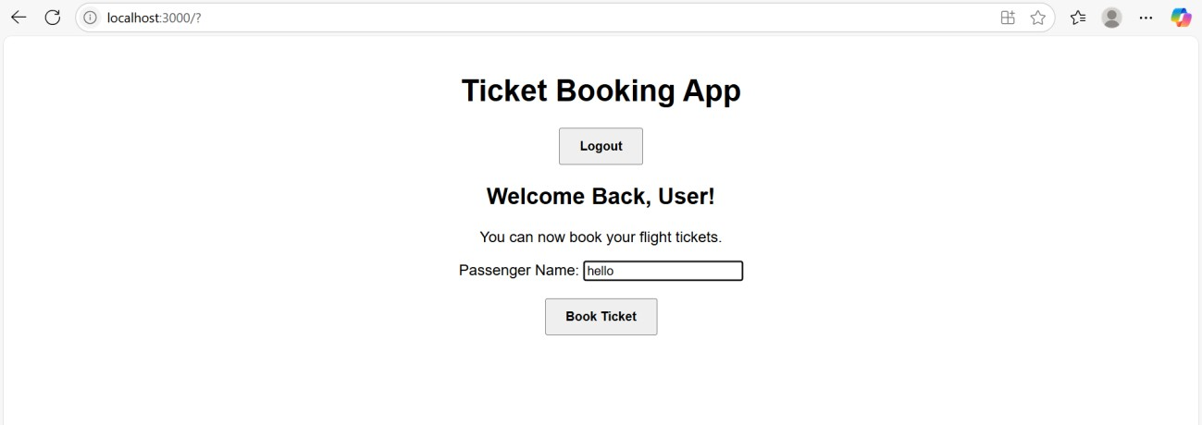

Onclick=bookticket

